|  |  |  |  |  |
| --- | --- | --- | --- | --- |
| What is Title I? Title 1 is a federally funded program that strives to provide equal opportunity and educational help for all student to succeed in school. Eligible schools receive extra financial assistance in addition to state and local funds. The name, Title I, is short for “Part A of Title I of Improving America’s Schools Act of 1965”, reauthorized by the No Child Left Behind Act of 2001.  Two Types of Title I Programs  Schools that have just over 35% of their students eligible for free and reduced lunches quality to be Title I Targeted Assistance Schools. In targeted assistance, Title I funds can be used only for those students identified as most in need of educational help. The funds, by law, may not be used for other purposes.  In schools that have over 40% of economically disadvantaged students, Title I funds can be used to benefit all students in the school, not just students who are identified as needing academic help. Those schools are designated a School-Wide Title I Schools.  North Rowan Middle is a  School-Wide Title I School. |  | What other resources are available?  A large variety of learning materials are available for checkout at the Title I District Office.  Please contact Kendall Fulham for specific details.  (704) 636-7500 |  |  |
|  |  | Principal:  Mr. Jonathan Clark  Assitant Principal:  Ms. whitney lowery  Assistant Principal:  Mrs. Sonya Galloway  Assistant Principal:  Mrs. Rebecca Hunter |  | North Rowan Middle School  Title I Information 2024-2025 |

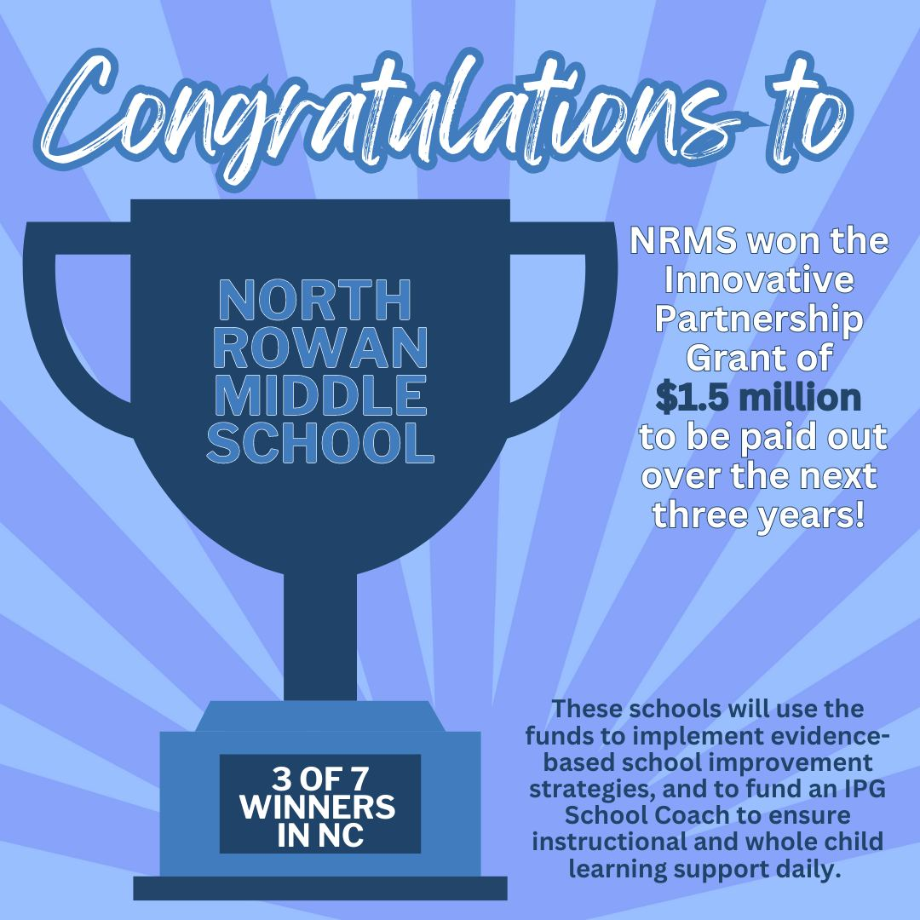

NRMS won a NCDPI projects grant awarding $500,000 per year over the next 3 years. This grant opportunity was available because NRMS is a Title I/CSI school and was only awarded to 7 schools in the state.

What Schools Receive Title I Funds?

Title I funds are used in schools with significantly high numbers of economically disadvantaged students. The measure used to make the determination as to which schools receive Title I funds is the percentage of students eligible for free or reduced lunches. Schools having 40% of more of their students receiving free and reduced lunches quality to receive Title I funds. North Rowan Middle school meets this requirement and is participating in the Title I program.

# Federal requirements for title 1 schools

According to the federal law that authorized Title I, each school receiving these funds must create a “school-home agreement” or equivalent written compact that specifies the duties and responsibilities of all parties directly involved in each child’s education. It is a federal expectation that each student, parent, classroom teacher and principal will read and sign the compact. While the compact is not a legal document, it is a pledge by all parties to do their parts to ensure each child’s success in school.